DBeaver Connect in Local

Make sure you already Installed Deaver and able to open the local as below.
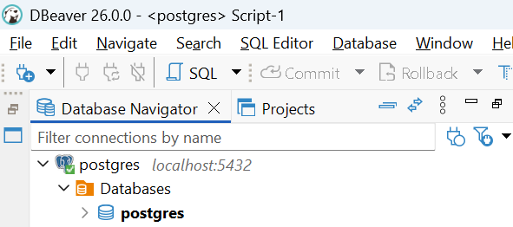

Get the DB Script for the Leads to create the DB in DBeaver app

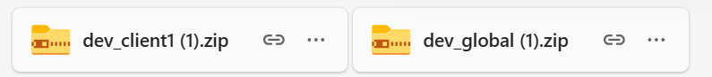

After Getting the files Extract the file.

Open DBeaver -> Create New Database

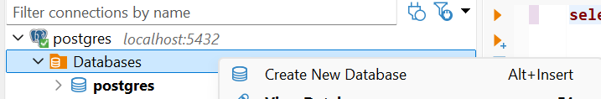
We need to create 2 DataBase one for client and one for Global

Below Steps is for Client:

Owner should your Enterprice id

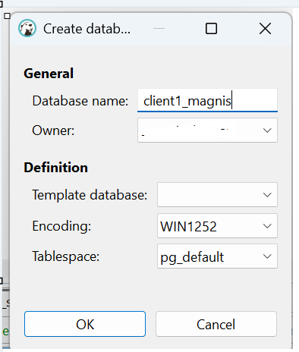

Click ok , DB will be created.

Right click on the DB Created and go as below.

Right click -> Tools -> Execute script

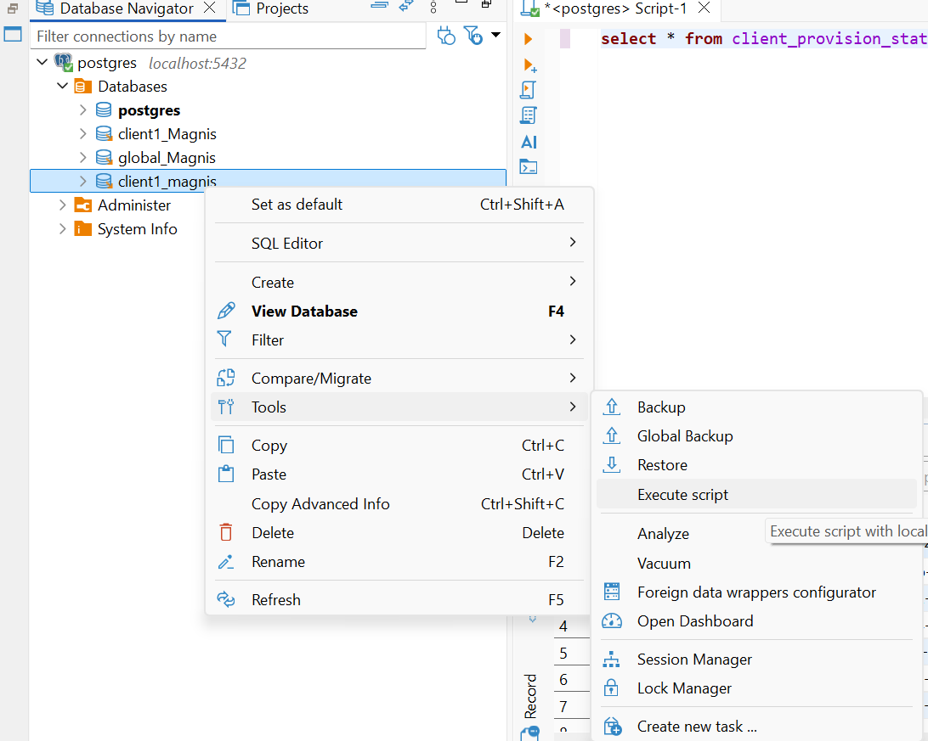

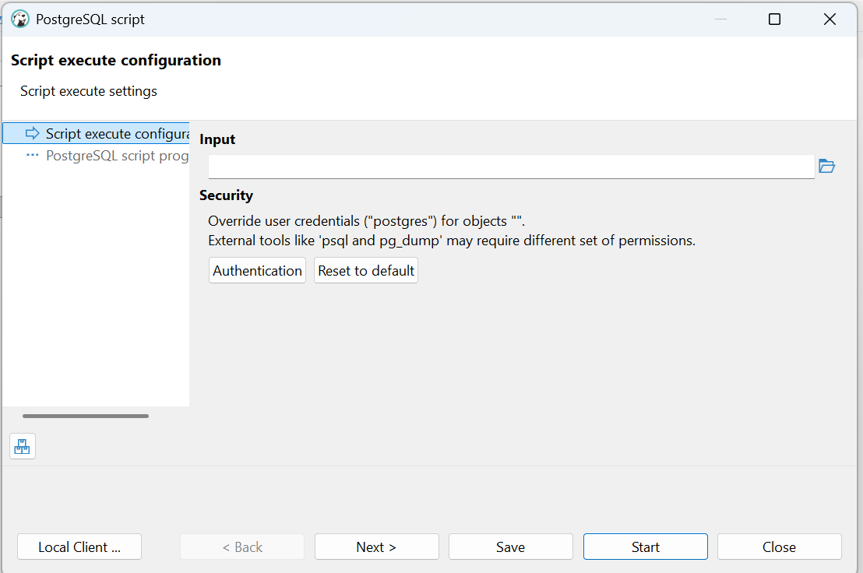

Click on Browes
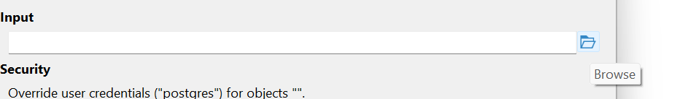

Upload the Client DB Script as below
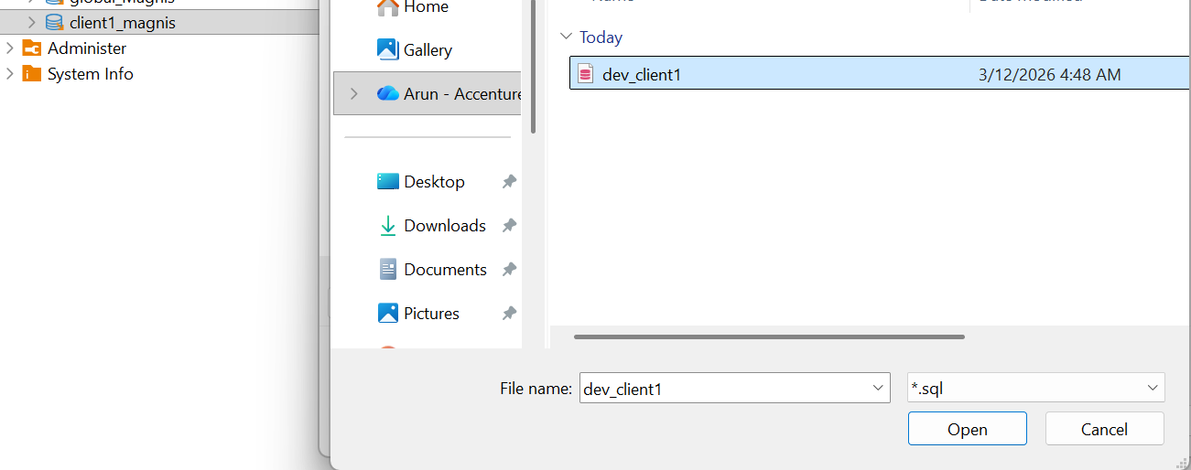
After upload, Click on Next.

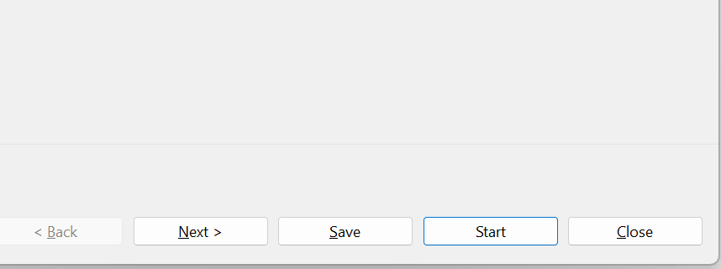

Then click on Start and it will run the script as below.

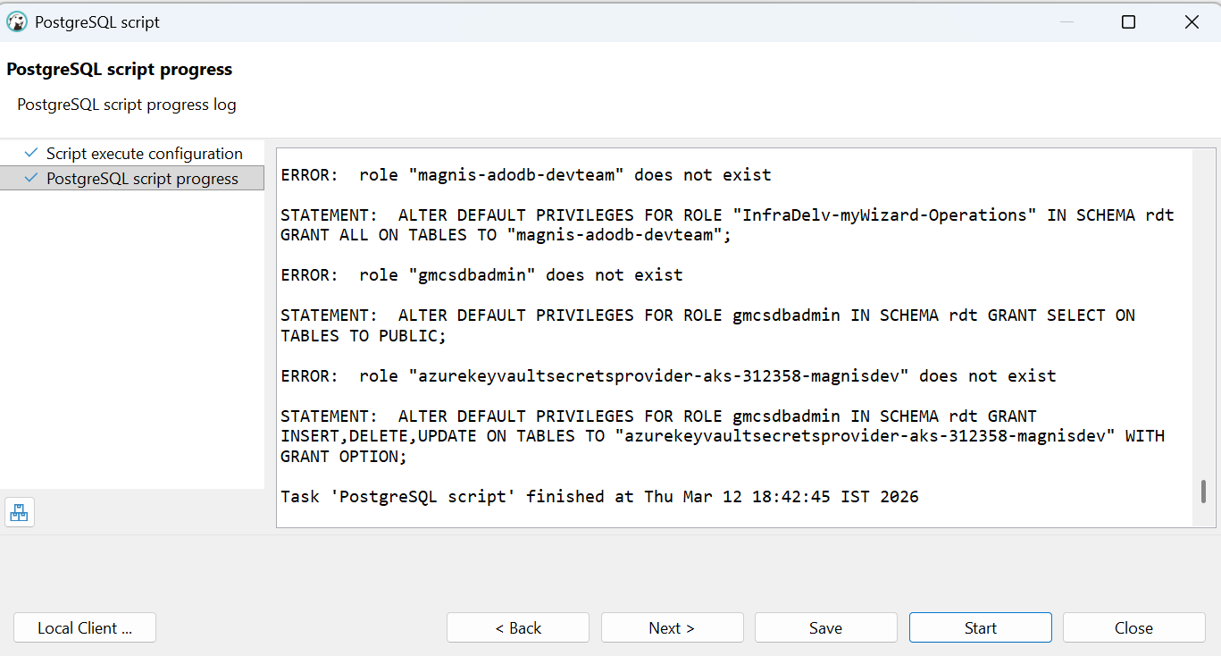
Note: if you get any warning message as below Ignore it.
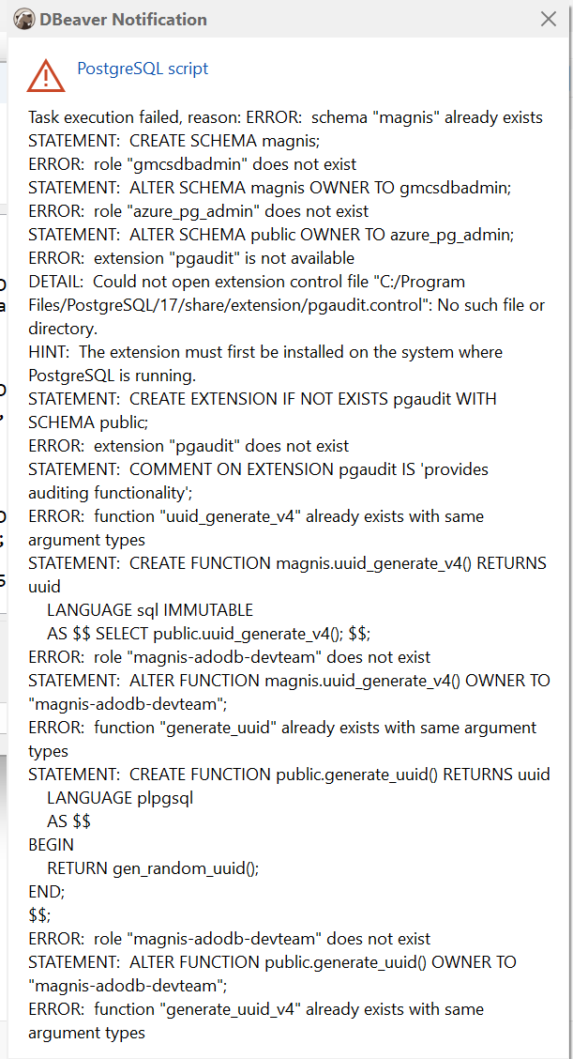

Then close the pop up and expand the client DB as below.

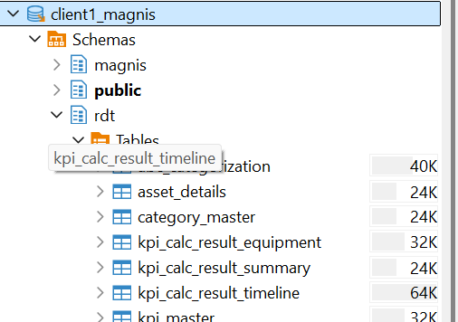

Below Steps is for Global:
Create DB for Global



Owner should your Enterprice id

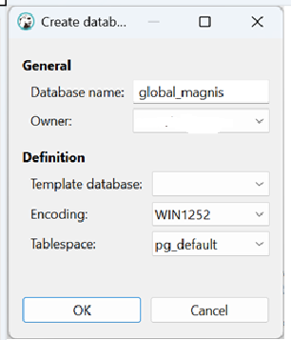

Click ok , DB will be created as below.

Note: if it’s not coming, Do a refresh.

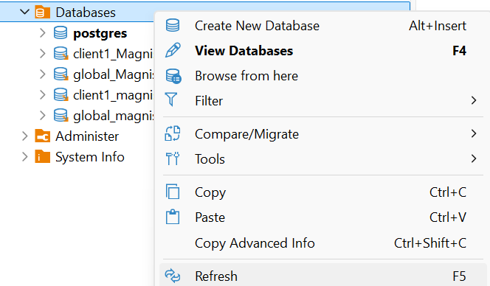

Right click on the DB Created and go as below.

Right click -> Tools -> Execute script



Click on Browes


Upload the global DB Script as below

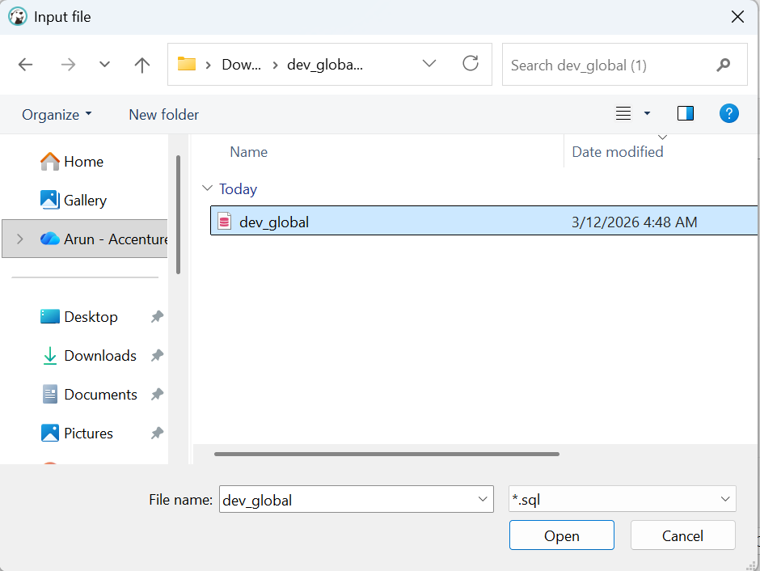

After upload, Click on Next.

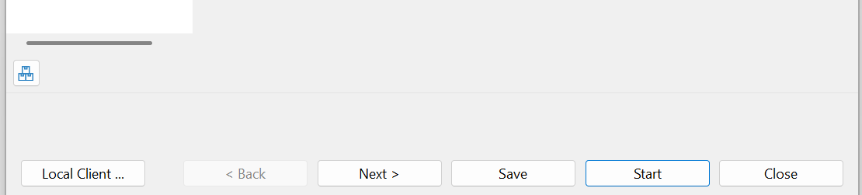

Then click on Start and it will run the script as below.

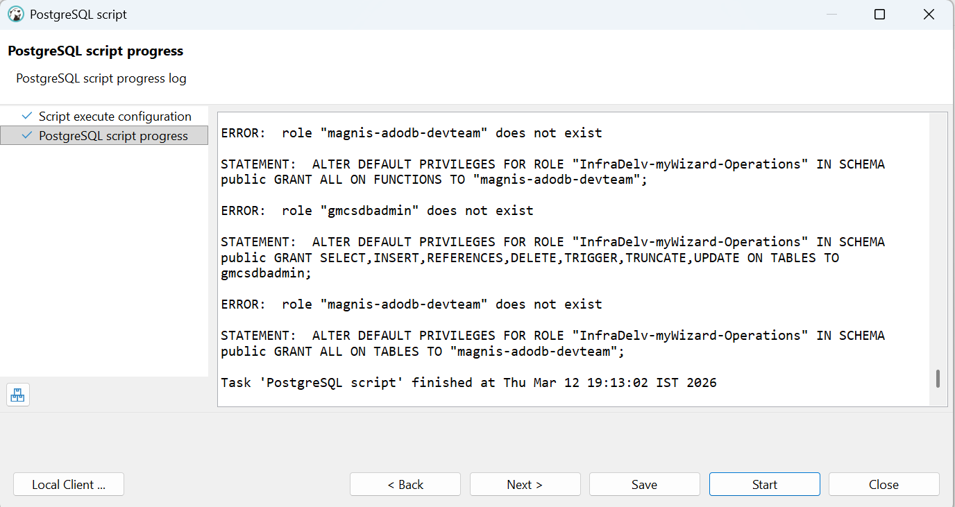

Note: if you get any warning message as below Ignore it.

Then close the pop up and expand the client DB as below.

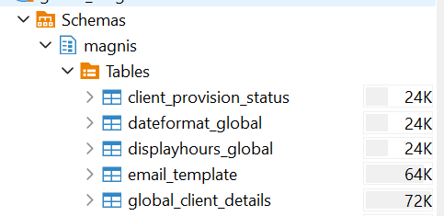

Your local DB Setup is done. Next step is to Run the .Net code.

